step-by-step installation guide for MySQL 5.1 (or higher) on Windows as a development machine. Other releases of MySQL should have similar installation process.

**Step #1: Download MySQL 5.1 for Windows**

**Step #2: Install MySQL**

Double click the MSI installer to start installing MySQL. You will go through a setup wizard so it's fairly simple. Just follow the installation instructions step by step.

(1) Welcome to the Setup Wizard for MySQL Server 5.1. Click Next to continue.

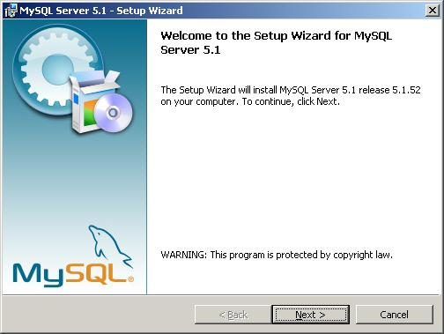

(2) Select a setup type - Typical, Complete, Custom.

Select Typical and click Next.

The default insllation directory will be C:\Programs Files\MySQL\MySQL Server 5.0\

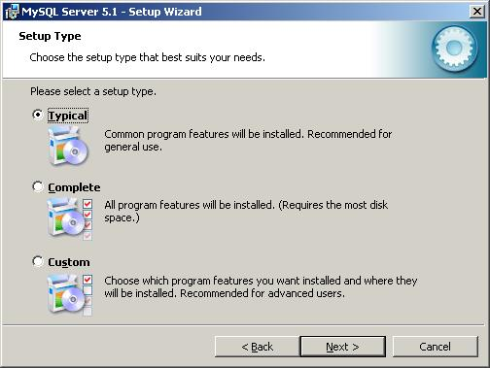

(3) Ready to install MySQL.

After review the settings, click Install. If you want to change any settings, click [Back] button.

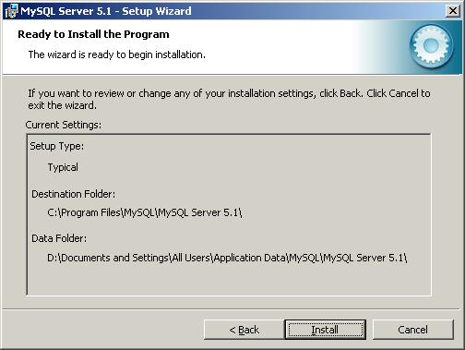

(4) Installation in progress.

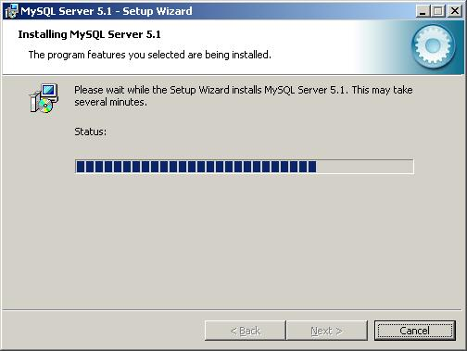

(5) More information about MySQL Enterprise Subscription.

This step is just an informational step for MySQL Enterprise Subscription. Click the [More...] button if you want to know more. Otherwise, click [Next] to go to next step.

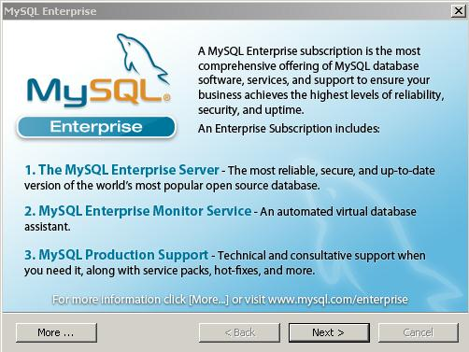

(6) Setup Wizard Completed.

Make sure you have selected 'Configure the MySQL Server now' checkbox if you want to configure it after clicking Finish button.

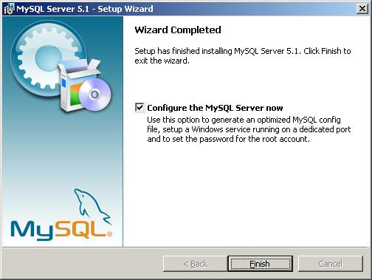

**What's next**

MySQL 5.1 provides an easy-to-use wizard to configure MySQL server instance. Next, we are going to go through detailed steps about MySQL server configuration.

[After installing MySQL 5.1 on Windows](http://www.geeksengine.com/article/install-mysql-v5.html), we will need to configure it. This article provides step-by-step MySQL server 5.1 configuration guide on Windows as a development box.

If you want to install multiple versions of MySQL on the same box, read this article [How to install two different versions of MySQL on the same computer](http://www.geeksengine.com/article/install-two-mysql.html) for more info.

1. Start MySQL Server Instance Configuration Wizard.

If you have selected the checkbox 'Configure the MySQL Server now' in the last step when [installing MySQL 5.1](http://www.geeksengine.com/article/install-mysql-v5.html), the configuration wizard should start automatically when you click the Finish button.

Alternatively, you can launch the wizard from Start menu. Start -> Programs -> MySQL -> MySQL Server 5.1 -> MySQL Server Instance Config Wizard.

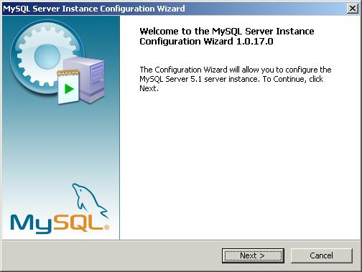

2. Select configuration type.

Select Detailed Configuration here. If this is the only MySQL server installed on your computer, you can select Standard Configuration.

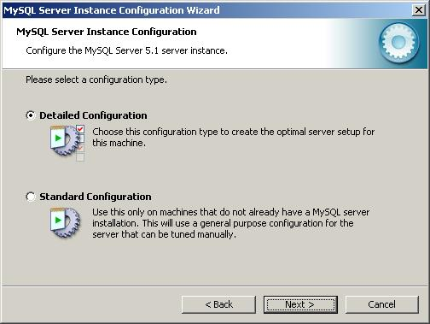

3. Select a server type.

As this MySQL server is running on a development box, select Developer Machine as the server type.

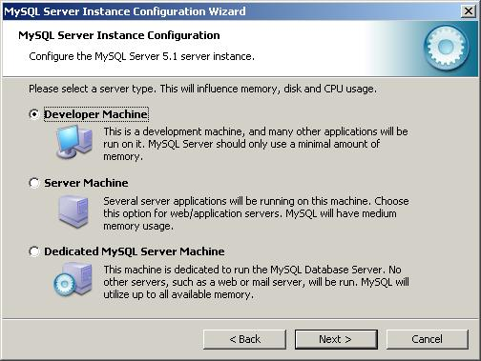

4. Select the database usage.

Depends on the purpose of your development box, you can select either Multifunctional Database or Transactional Database Only.

Here we selected Transactional Database Only.

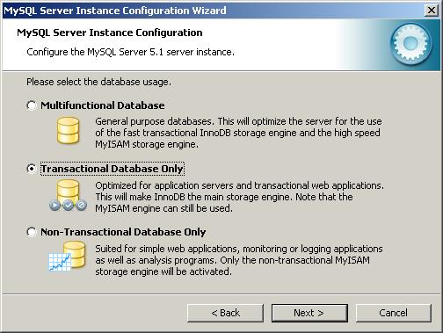

5. Set InnoDB table space settings.

InnoDB table type is the storage engine for a transactional database. Use the default settings here.

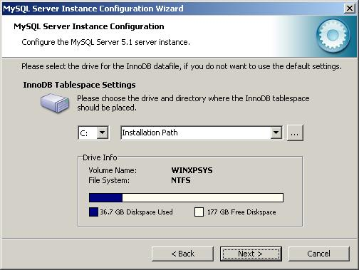

6. Set the database engine's concurrent connections option.

Here we selected Online Transaction Processing (OLTP) as it is the most common use of MySQL server.

If the MySQL server on your development machine is used for decision support such as data warehousing or data mining, select the first option.

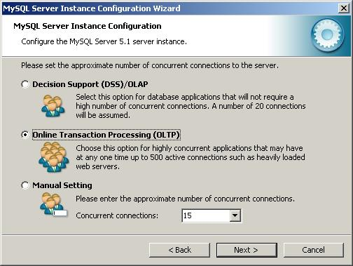

7. Set networking options.

By default, make your selection the same as screenshot below. If port 3306 has been used by another instance of MySQL server, you can select port 3307 or a different port. This will allow [two instances of MySQL server to be accessed via different ports on the same box](http://www.geeksengine.com/article/connect-to-two-mysql.html).

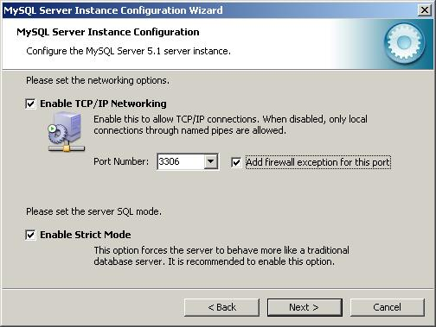

8. Select the default character set.

By default, the Standard Character Set is selected, but you may want to select the second option - Best Support For Multilingualism. This allows our database to store text in many different languages.

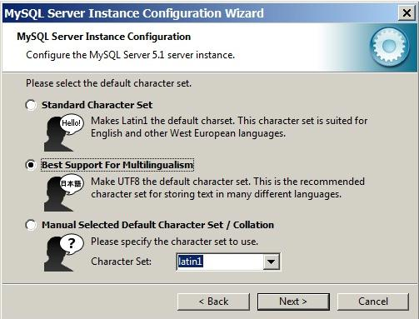

9. Install MySQL server as a Windows service.

Below is the recommended way to run MySQL server on Windows. Making the service name as MySQL51 clearly identifies the service as a MySQL server version 5.1 database engine because you might [install other versions of MySQL server on the same machine](http://www.geeksengine.com/article/install-two-mysql.html).

You might also want to check **Include Bin Directory in Windows PATH** if you want to operate MySQL from command line.

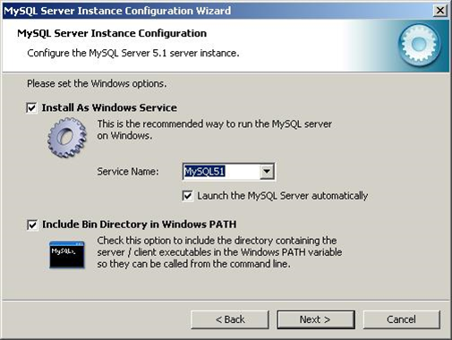

10. Set the root password.

Set a new password to the root account. Enter the same password to all three boxes. See below.

Don't select the Create An Anonymous Account checkbox. This can lead to an insecure system.

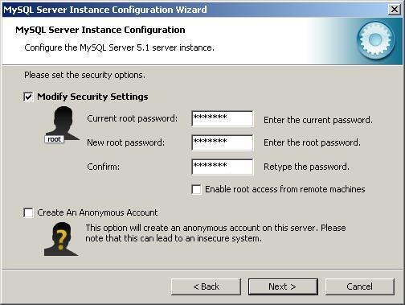

11. Ready to execute the configuration.

Now everything is ready to execute. Click [Execute] button.

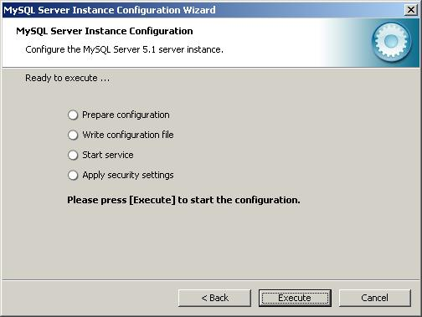

12. Configuration successfully completed.

The configuration file has been created successfully. Click [Finish] to close the wizard.

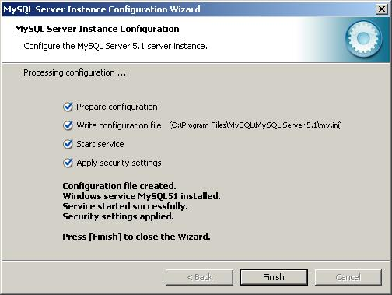

Happy Configuring!